Hatim Mala

Hatim.mala@han.nl

Mathematical modelling and Model-predictive controller design for a DHW system consisting of a heat pump, electric heater, and a stratified water storage tank

OSEM: Modelling & Controller Design

Work Package 4 Documentation

Table of Contents

1. Introduction: 3

1.1 Background 3

1.2 Definitions 3

1.3 Activities 3

1.4 Method 4

2. Literature Review: 5

2.1 Literature review on the system’s layout 5

2.2 Modelling & Controller Design Software tools: 7

2.3 Review on Control Strategies: 8

3. System Description: 10

3.1 The generalized system layout 10

3.2 System layout for the 1st iteration: 11

4. Plant Modelling: 13

4.1 Solar Panels model: 13

4.2 Heat Pump Model: 14

4.3 Storage Tank Model: 16

4.3.1 Conduction: 17

4.3.2 Convection: 17

4.3.3 Heat Loss: 18

4.3.4 Tapping: 18

4.3.5 Heating: 18

4.4 Simulink Implementation: 19

5. Controller Design 22

5.1 The Control Goals: 22

5.2 Model Predictive Control: 22

5.3 The Optimization problem: 24

5.5 Tuning the MPC parameters: 26

5.5.1 The controller sampling time: 26

5.5.2 The prediction horizon p: 26

5.5.3 The control horizon c: 27

5.5.4 The output weight matrix Q: 27

5.5.5 The input weight matrix R: 28

5.6 Controller Design in Simulink: 29

5.7 Verification of the design 35

5 Controller Simulations: 37

7. Discussion & Conclusions 40

8. Controller Implementation: 42

7.1 Raspberry Pi Support from Simulink 42

Bibliography 44

# Introduction:

## Background

This document describes the activities and results of Work Package 4 (WP4) of the project Open-Source Energy Manager. While WP1 dealt with the package of requirements, WP2 with the selection of the development tools and platforms, and WP3 with the system architecture, this WP deals with the design, realization and test of the energy management system. In this document, various terms are used, defined below.

## 1.2 Definitions

**Plant**: The plant consists of solar panels, a domestic air-water heat pump, a boiler tank for domestic hot water, and their interconnections.

**MPC**: The model predictive controller, or simply the controller, ensures the tank temperature is kept within the required values. The controller achieves this goal in an “optimal manner”. To do so, the controller solves an optimization problem which includes an objective function (optimal condition), equality constraints (the plant dynamics), and inequality constraints (physical limits of the plant).

**Weather prediction module**: This module is responsible for supplying the controller with forecasts of the solar irradiation and ambient temperature.

**Actuators**: The actuators in the plant are the electric heating element, and the heat pump compressor.

**Energy management system**: The controller and the weather pre- diction module together are referred to as the energy management system.

**Disturbances**: By definition, these are variables that affect the plant performance but can't be manipulated. The measured disturbances include the solar irradiation, ambient temperature, the hot water usage profile, and the temperature of the return cold water.

## 1.3 Activities

Activities in this WP:

* Literature research on the following topics: heating system layout, software tools for HVAC modelling and controller design, and advanced control strategies in HVAC.
* System Layout: The system layout: Heat generation, transport, storage and delivery will be explained.
* System's modelling: Developing the dynamic model of the system.
* Internal model development: Developing a state space representation of the system. This will be used an internal model for the MPC.
* Model-predictive Controller (MPC) design and verification.

* MPC deployment into hardware target.

## 1.4 Method

The approach in this work package follows the conventional control systems design bow, depicted in the figure below. It starts with qualitative description of the uncontrolled process, where the inputs, outputs, states, and disturbances are defined. This is followed by a quantitate description of the process in the form of differential equations. The set of differential equations constitutes the dynamic model. This model is not only useful to create simulation scenarios, but also used within the controller to predict the process variables.

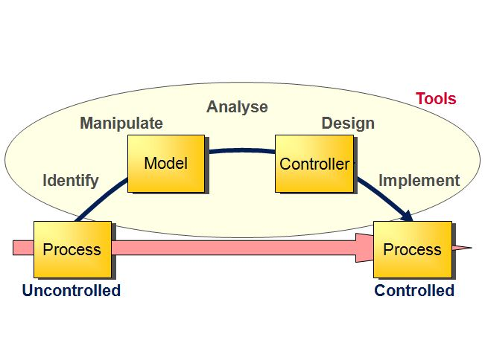

Figure 1: Control System Design Bow

In the controller design phase, the control goals are defined and motivated. It is shown that model predictive controller (MPC) is a suitable candidate for the control goals. The MPC problem is then introduced, with the various parameters of the design explained. The design is concluded with verification via simulations.

The report of this work package ends with describing the controller implementation and deployment into hardware. The tests results on the controlled process are reported in a separate work package document.

# Literature Review:

## 2.1 Literature review on the system’s layout

In this section, a literature review is carried out to find what is the system layout for a heating system that incorporates a heat pump, a buffer tank and daily hot water usage. The system layout describes how the heat generation equipment (Heat pump, gas boilers, electrical heaters) are connected to thermal storage tanks, and how the generation and storage equipment are connected to the heat delivering equipment. In [1], a system with a ground-source heat pump, a stratified storage tank and an auxiliary heater is considered. The system layout is shown in figure 2.

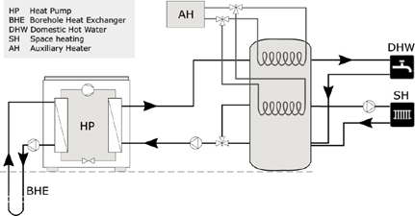

Figure 2: System Layout reported in [1]

It should be noted that the study in [1] was carried out in Sweden, where ground-source heat pumps are dominant, whereas in the Netherlands, air-water heat pumps are dominant in the market. Furthermore, the use of a storage tank with two separate heat-exchangers may not be suitable for the majority of the Dutch dwellings, as conversations with experts and practitioners point out that finding a sufficient space for the stratified tank is challenging.

An alternative system layout is also presented in [1] and shown in the figure below. The authors argue that this system layout is more suitable for variable speed compressor heat pumps. In this layout, the storage tank is only used for DHW purposes.

Various other system configurations have been reported in literature. In [2], the system configuration consists of a PVT, heat pump and two storage tanks. In [3] , the system consists of an air-water heat pump in parallel to a gas boiler. Other examples of various system layouts are reported.

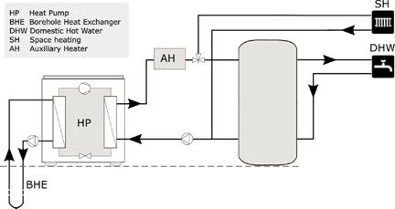

Figure 3: An alternative system layout option [4]

It becomes clear that any system configuration is greatly influenced by the geographical location of the building, the type and insulation level of the building, the country's regulations, and the profile of the thermal demand in the building. For these reasons, a better approach to arrive to a system configuration would be to consider the specific building for which the application is intended, propose a system layout based on the load profile and the available equipment, and discuss the proposal with experts, manufacturers and installers.

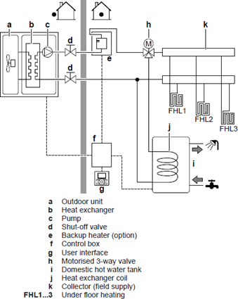

Figure 4: System Layout proposed by Dakin [5]

DAKIN industries is one of leading manufacturers of heat pumps with a large market share in the Netherlands. The Figure 4 is extracted from a DAKIN reference guide [4] for an air-water heat pump comparable to the size of the heat pump developed in HP-Launch. In this configuration, the heat pump is the main heat generation source for both space heating and DHW. When the heat pump cannot meet the demand due to defrosting or unfavorable weather conditions, a backup heater is used. The results from project HP-launch (citation needed) indicate that without a heat storage medium, there is no room for optimizing the heat pump operation as the heat pump will be operating at its maximum for the entire time.

## Modelling & Controller Design Software tools:

The design of an advanced control strategy requires a model of the controlled process. Heating, ventilation, air-conditioning and cooling (HVAC) of buildings has been a field of study for over 40 years. As a result, there exists a wide range of software products for simulation of the energy performance of buildings. In [6], an overview of these products is provided. In [7], simulation tools are divided into several categories. This can reduce the burden of selecting a simulation tool. The categories are:

* Tools for pipe/duct sizing.
* Tools for equipment sizing and selection.
* Tools for energy performance analysis.
* Tools for system optimization.
* Tools for control analysis and control optimization.

It's clear that the tools that belong in the final category are the ones of interest for the purpose of this project. In order to find out these tools, the database (BEST) [8] created by the US department of energy is used. This is a directory of all HVAC software can be searched based on capabilities. The search results show that the most prominent software products under this category are ESP-r [9] , EnergyPlus [10] and TRNSYS [11] . In [12] and [13] a comparison is made between the performance of TRNSYS and EnergyPlus, the findings show that both tools provide similar results that agree with experimental data. For the purposes of this project, EnergyPlus is preferable because it is an open-source platform.

Although the tools mentioned above offer a high degree of sophistication and detail in terms of thermal energy performance, they do not provide capabilities for advanced control systems design comparable to, for example MATLAB. On the other hand, MATLAB provides an efficient platform for the design, verification and implementation of advanced controllers, yet has limited capabilities in simulating building systems thermal performance.

Co-simulation has recently been exploited as a way to combine the strength of two software tools in order to execute. For example, using EnergyPlus to simulate the plant and MATLAB to to simulate the controller, while data is being passed between the two at each sampling interval, as explored in [14] and [15] .

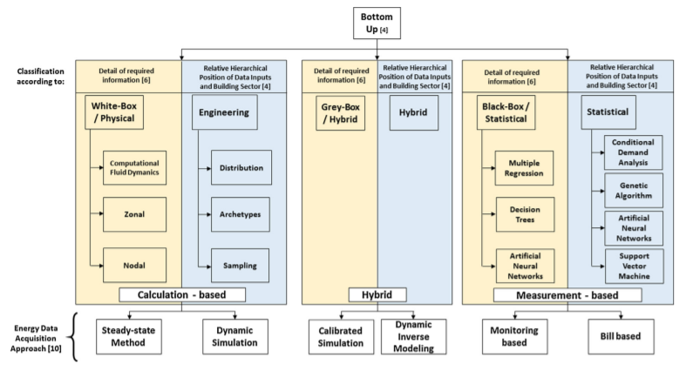

Figure 5: HVAC Modelling approaches [16]

## Review on Control Strategies:

Broadly speaking, building control strategies can be classified into rule-based strategies and model-based strategies [17]. The figure below shows a classification of these control strategies.

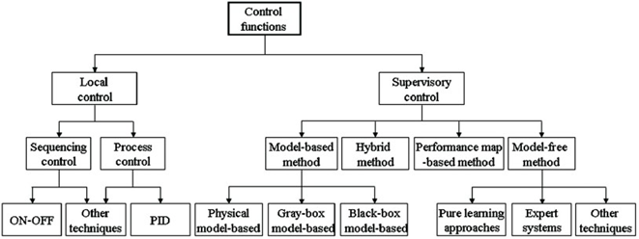

Figure 6: Classification schematic of control functions in HVAC systems [18]

There is hardly any scientific literature published on the rule-based methods. This could be due to the fact that they are developed by heat pump manufacturers and considered propriety. However, it is understood that the rule-based methods rely on the heat-pump heating curve, ambient temperature, and threshold values in an “if-condition-then-action” fashion [19].

Mode-based strategies has been reported in literature since as early as 1990. In [20], a comprehensive review of Advanced control systems engineering for energy and comfort management in a building environment is offered, which references over a hundred articles on the subject.

Despite the extensive research and promising results, advanced control strategies in built environment did not find their way into commercial application. This is attributed to the higher computational power required compared to rule-based techniques, the extra sensors, and the need of an accurate model of the house, which makes it difficult to adapt to the different characteristics of each household. A comparison between rule-based and model-based methods is summarized in [20] and presented in the table below.

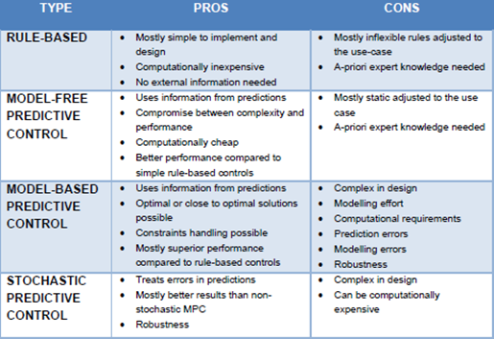

Figure 7: Summary of pros and cons of control strategies applied in built- environment. [20]

# System Description:

## 3.1 The generalized system layout

The ongoing activities in parallel work packages (See activity reports WP1, WP2 and WP3) have resulted in various decisions regarding software, firmware, and hardware. Among these decisions is the system architecture. The system's P&ID is shown in the figure 8.

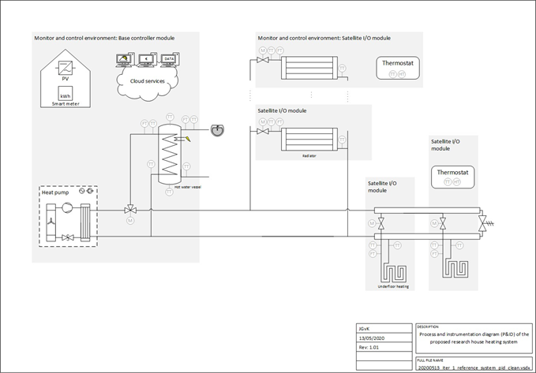

Figure 8: System Layout

This architecture is consistent with the reviewed literature. As depicted in the figure, the main heat source in the system is the heat pump. The heat pump includes a booster (not shown in the figure, also not controlled in this application). The booster is an electric heater that can be used to supply heat when the output of the heat pump cannot meet the demand, or when the heat pump is in defrosting mode, or when the heat delivery device (e.g. radiators) require higher temperature than the heat pump can deliver. The open-source controller in this application controls the heat pump compressor set-point.

A three-way valve controls the ratio of the heat that is delivered to the space heating devices (Radiators and underfloor heaters) and the water storage tank. The water storage tank is responsible for delivering the daily hot water (DHW) demand. Note that the storage tank includes an electric heating element whose purpose is to meet the DHW demand when heat pump is in defrosting mode, and to maintain the water temperature according to the minimum required by the health regulations. The open-source controller in this application controls heating element power set-point.

The presence of a storage tank is crucial for the system as it allows for optimization. Clearly, without storage, the instantaneous heat demand must be generated on the spot. Storage also allows for the energy manager to make use of predictions. This will be elaborated in later sections. Two types of heat delivery devices are depicted in this system layout: radiators and underfloor heaters. The design of the energy manager will assume the presence of both devices. The reason is that the reference house selected for this study uses radiators. However, refurbishments allow for replacement of the radiators with underfloor heaters, which requires less fluid temperature compared to the radiators. In addition, underfloor heaters have a higher heat capacity, this property can be exploited as means of heat storage.

## 3.2 System layout for the 1st iteration:

Due to the project constraints, it was decided to focus the attention of the 1st iteration of the project on the control of the storage tank for DHW. The findings from this iteration will contribute to the generalized system mentioned in (3.1). Therefore, for this iteration, the design, simulations, and implementation will be focused on the system depicted in the figure below:

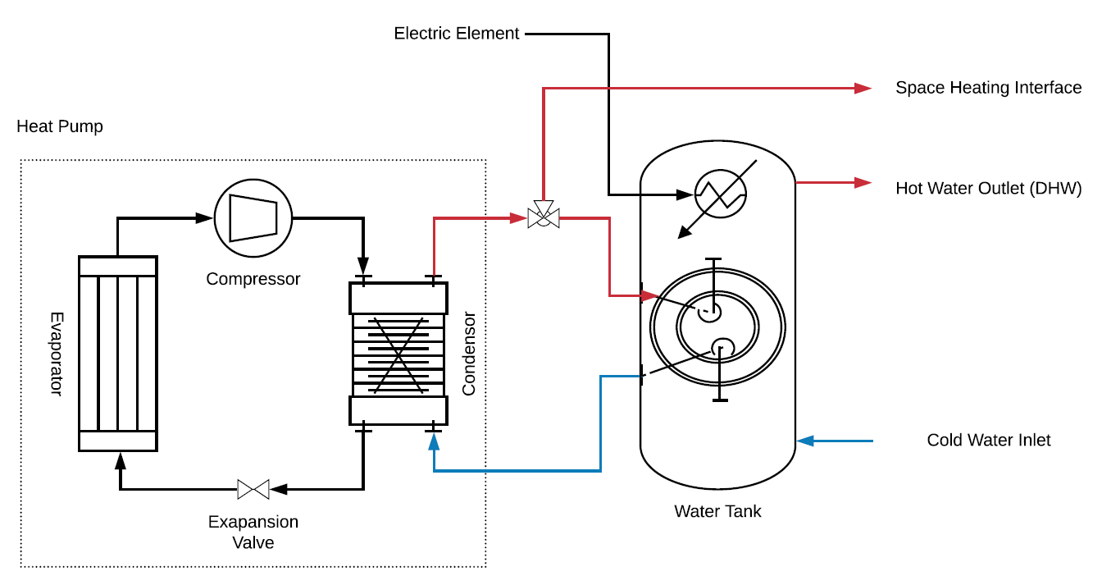

Figure 9: System layout for the 1st Iteration

|  |  |  |
| --- | --- | --- |
| **Goal of Control** | Optimal* control of the water temperature in the tank | |
| **Process inputs and actuators** | **Input variable** | **Actuator** |
| Electric power to the heat pump. | Heat pump compressor |
| Electric power to the heating element. | Heating element in the tank |
| **Process output (Sensors)** | **Output variable** | **Sensor** |
| Temperature of the water in the tank | 5 temperature sensors placed across the height of the tank. |
| **Disturbances** | 1. Ambient temperature. 2. DHW draw-offs. | |

Remarks:

* The purpose of the system is to deliver DHW to the users. The DHW must conform to certain temperature requirements. The goal of the controller is to ensure that these requirements are met in an optimal manner. Optimality will be elaborated upon in the controller chapter.
* The control action is performed via the two heating devices in the system; the heat pump and the electrical heater, as shown in the figure.
* The controlled variables are the temperature of the water inside the storage tank. Due to the buoyancy effect, the temperature of the water in the tank is not uniform. Therefore, 5 temperature sensors are placed in the tank.
* Two main disturbances are considered. The ambient temperature as it has a direct influence on the heat pump’s coefficient of performance (COP). In addition to the draw-offs (The hot water usage profile) as it has direct influence on the temperatures inside the tank.

# Plant Modelling:

As mentioned in section 2.3, the design of a predictive energy management strategy (model predictive controller) requires a dynamic model of the plant. This dynamic model is used by the MPC internally to predict the future states of the plant as depicted in the figure below.



Figure 10: Structure of the Model-predictive controller

The plant is divided into subsystems. Namely: the solar panels, the heat pump, the heat exchanger and the buffer tank. The following sections present the dynamic model of each subsystem.

## 4.1 Solar Panels model:

The electric power generated by the roof solar panels [*W* ] is given by:

Where [] is the number of the roof solar panels. [ W/m2] is solar irradiation. is the efficiency of the solar panel. Due to the semiconductor properties of the photovoltaic cell, its performance decreases with temperature, this effect can be characterized by:

Where is the reference efficiency. is the temperature coefficient. The values of and βref are given by the manufacturer at = 25[C]. is the cell temperature, which can be estimated by the approximation:

Where [C] is the ambient temperature. [C] is the nominal operating cell temperature, which is defined as the cell temperature measured under open-circuit when the ambient temperature is 20 [C], irradiation is 0.8 [kW/m2] and wind speed is 1 [m/s].

## Heat Pump Model:

Dynamic modelling of heat pumps has been the subject of many publications, including project HP-Launch by this research group. The model structure and the level of detail depend on the goal of the model. For the goal of designing a model predictive controller, the goal of the model is to estimate the temperature of the condenser outlet as a function of the compressor power and the ambient temperature. Therefore, the internal phases of the heat pump refrigerant will not be modelled. Moreover, when considering the time scale of the controller, the internal states of the refrigerant) become irrelevant.

The coefficient of performance of a heat pump is defined as the ratio between the heat delivered by the heat pump [W], to the work performed by the heat pump compressor [W].

According to Carnot cycle efficiency, the COP can also be obtained by:

Where and [C] are the temperatures of the condenser and evaporator, respectively. Note that the expression above gives the theoretical maximum COP. Practically, under the same conditions, the COP will be below this value, due to heat losses.

In [20], the Coefficient of Performance (COP) from over 100 domestic heat pump models was collected, along with the temperature rise across the heat pump. Curve fitting was used to obtain a relationship between the COP and the temperature difference as shown in the figure:

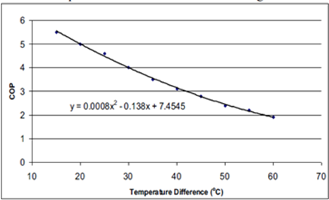

Figure 11: Relationship between COP and condensor/evaporator temperatures [21]

Now that the COP is characterized in terms of the evaporator and condenser temperatures, what is left is to describe the dynamics of the evaporator and condenser. These dynamics can be modelled via the heat balances depicted in figure 11

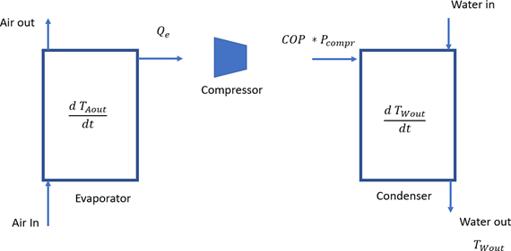

Figure 12: Heat balance in a typical air/water heat pump

Thus, the heat balance of the evaporator can be written as:

Where [*J/K*] is the heat capacity of the evaporator. *Tain* and *Taout* [*K*] are the temperatures of the air entering and leaving the evaporator, respectively. [*Kg/s*] is the mass flow rate of the air through the evaporator. [*W* ] is the rate of thermal energy delivered by the evaporator. Note that the last term can be rewritten as:

Similarly, from the figure above, the heat balance of the condenser can be written as:

The set of equations presented above characterize the heat delivered by the heat pump as a function of the ambient temperature and the compressor power.

## Storage Tank Model:

The water tank represents the storage element in this system. Thermal energy is added to the storage via a spiral heat exchanger. Hor water can be extracted for DHW use from the top of the tank, while cold water is added from the bottom to maintain constant water volume. The layout of the storage tank is shown in the figure

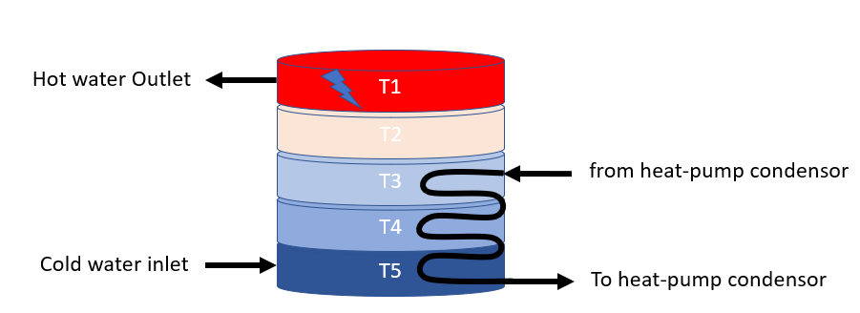

Figure 13: Layout of the storage tank

A distinct property of such storage tank is the *stratification* of water; Due to the fact that the density of water decreases as its temperature increases, the warmer the water the higher up the tank it moves. This creates distinct “layers” of water with different temperatures inside the tank. Although this is desired from a storage perspective (Maintaining the higher layers at higher temperatures without the need to heat up the lower layers), stratification introduces complexity to the dynamic model.

An approach to model the stratification behavior is to assume the tank is divided into several layers as shown in the figure, with each layer having a single temperature, and work out the heat balance for each layer independently. This is known in the literature as a 1-D model, as opposed to more complex models that assume the temperature is not only distributed vertically, but also in the other coordinates.

The main choice is then the number of layers within the tank. Clearly, The higher the number of layers chosen, the more accurate the stratification effect is captured. However, this comes at the expense of the number of equations required (For each layer, one differential equation). Considering the model will be used as a predictive model in the MPC, a highly complicated model is not desired from a computational expense point of view. Furthermore, if the temperatures are not measured withing the tank, an estimator is needed to provide the temperature values.

Therefore, the choice for the number of layers is the minimum number of layers capable of providing a model that can estimate the *energy content* of the tank with sufficient accuracy. After consulting with TNO, who conducted simulations with different number of layers, the choice is 5 layers. The storage tank was subsequently equipped with 5 thermocouples as well.

The heat balance equation for one layer of the tank can be written as:

In the next section, each term in the balance will be elaborated.

### Conduction:

Conduction is the heat transfer between adjacent layers in the tank. This can be elaborated for layer 1 as:

Where is the Heat conductivity times area [W/mK ]. And dx is the length of the layer [m]. For the layers 2 to 4:

And finally, for layer 5:

### Convection:

Convection is the unidirectional heat transfer due to the movement of warmer water from the bottom layers upwards. The time constant of convection dynamics is much faster compared to the other heat transfer terms in the balance equations. Therefore, modelling the dynamics of convection in the form differential equations will force the choice of a very small sampling time in the simulation. This will cause the prediction algorithm to become inefficient.

Instead, the convection will be modelled “statically”. First, the temperature of each layer is calculated from the heat balance equation, excluding the convection term. Then, a check will be made to find where *inversion* occurs (Inversion refers to the unrealistic situation in which a layer will have a higher temperature than the one of the layers above it). This check can be made with the following pseudocode:

for i = 4:-1:1

if T(i+1) >= T(i)

inversion_Index = i+1;

break;

end

end

If no inversion is present, then no heat transfer due to convection will take place. However, if inversion is detected, then is calculated using the following equations:

And:

For the unaffected layers (below the inversion),

### Heat Loss:

The stationary heat loss refers to the heat loss from the water in the tank through the tank walls to the surrounding environment. This is characterized by:

Where N is the number of layers in the tank. is the ambient temperature outside the tank. is the temperature of layer n. is the external surface area of the tank, and is the heat loss coefficient of the tank surface [W/m2K].

### Tapping:

Tapping refers to the change of the thermal energy content of the tank due to extraction of DHW and simultaneously adding cold water at the inlet. For the lowest layer, where cold water is added, this change in energy is captured by the equation:

And for the layers 1 to 4:

### Heating:

Heating refers to the thermal energy added to the tank via the heat exchanger coil that runs through layers 3 to 5. Here, it is assumed that the coil itself is divided into 3 sections (A, B,C). It’s also assumed that the temperature within each coil section is constant. Based on these conditions, the heat flux to the third layer can be written as:

Where is the temperature of the incoming water to the heating coil from the heat pump condensor.

Similarly for layer 4:

And for layer 5:

Where is the temperature of the return water from the heating coil to the heat pump condenser.

The table below lists the values of the physical parameters of the storage tank model.

|  |  |  |
| --- | --- | --- |
| Parameter | Definition | Value |
| k | Heat conduction coefficient of heating coil | 0.469 kW/K |
|  | Specific heat coefficient (at constant pressure) of water | 4.18 kJ/(kg*K) |
|  | Mass flow of heating water through coil | 0.167 [Kg/min] |
|  | Length of layer | 0.2147 m |
|  | Conductivity | For water: 0.000591 kW / (m K)  For steel: 0.0144 kW / (m K) |
|  | Temperature of inlet water | 10 °C |
|  | Heat capacity of single layer (including water volume and wall capacity) | 191.4 kJ/K |
|  | Heat conductivity times area; tank (and fluid) property | 2.072e-4 kW*m/K |
|  | Heat loss coefficient of outside of tank | 3.82 W/(m2K) |
|  | Outside area of tank | 1.69 m2 |
|  | Time-constant for convection speed. | 10 s |

Figure 14: Physical Parameters of the storage tank

## Simulink Implementation:

The mathematical models presented in the previous section were implemented in Simulink. The figures below provide an overview of the implementation of the various subsystems. Due to the complexity of the inner sub models, only the outer layers are shown.

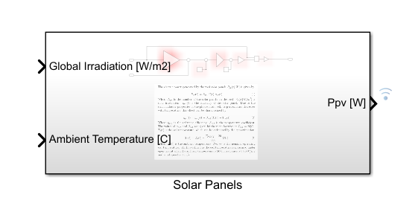

Figure 15: Solar panels Model

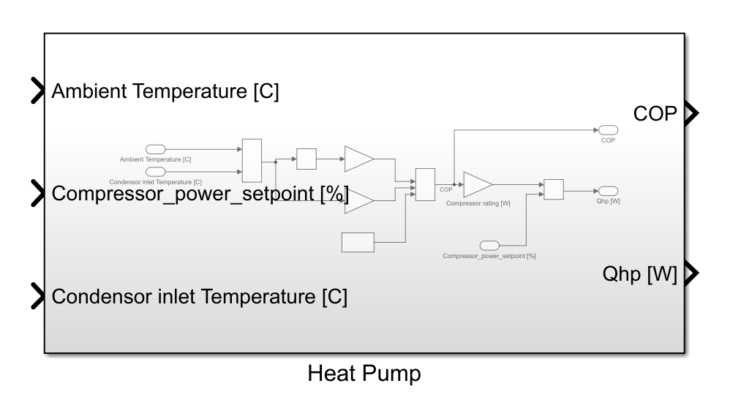

Figure 16: Heat pump subsystem

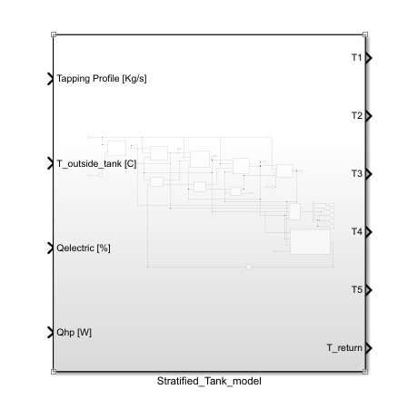

Figure 17: Simulink Model of the stratified tank

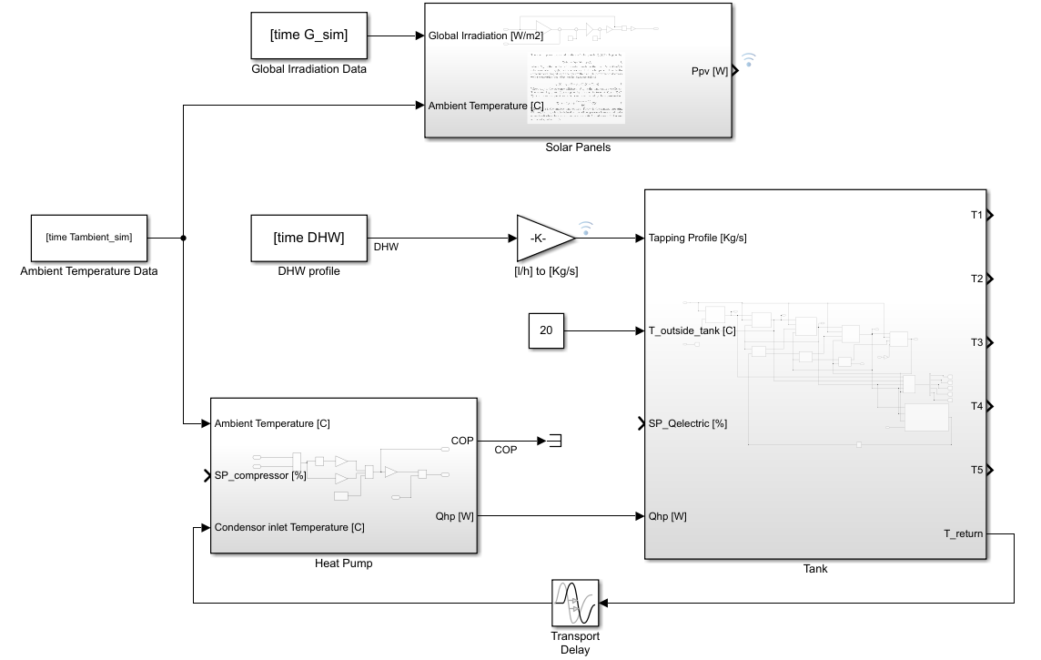

Figure 18: Overview of the complete plant model in Simulink

Remarks:

* The outputs of the plant model are the temperature gradient inside the buffer (T1 to T5).
* For the purposes of the simulation, the model uses ambient temperature and global irradiation datasets obtained from KNMI.
* The daily hot water (DHW) usage profile is generated by a software developed by the university of Kessel.
* The temperature of the tank surroundings is assumed to be constant at 20 C.
* The model is simulated with a sampling interval of 60 [s].
* The compressor setpoint, and the electric heater setpoint, are the actuator values to be determined by the model predictive controller (MPC).

# Controller Design

## 5.1 The Control Goals:

The goals of the controller can be stated as follows:

1. To satisfy the DHW demand with the desired temperature setpoint.

B) To achieve goal (A) in an optimal manner. In general, to “optimize” is to maximize or minimize a specific quantity. In this sense, optimality can be defined in several different ways according to the user viewpoint. For example, optimality can be defined as minimizing the cost of energy [€]. It could also be defined as minimizing the energy itself [KWh]. From another point of view, optimality can be maximizing the usable energy content of the storage tank. In this first iteration of the project, the definition adopted for optimality is a hybrid of the 3 examples mentioned. In this specific application, the cost function is formulated in such a way that the heat pump is always prioritized over the electric heater, taking advantage of the high COP of the heat pump, the electric heater will contribute when the COP is low and the temperature in the tank is highly deviating from the setpoint. Also, the cost function is formulated such that the upper layers of the tank will be maintained at higher temperatures while the lower layers will be allowed to deviate, thereby contributing to maximining the usable energy content. The exact formulation of the cost function is elaborated in this chapter.

Satisfying the DHW demand means ensuring that hot water is available whenever the users request it. Classical controllers (such as PID) are excellent at tracking a given setpoint and reacting to disturbances. However, they inherently lack the ability to predict disturbances or changes within the system as they merely react on the error. Therefore, using a classical controller, we will be able to maintain acceptable temperature in the tank. However, a situation might occur where there is too much heat in the tank for example.

Furthermore, questions related to costs cannot be addressed within the PID paradigm. For example, the question of which heater (Heat pump or electric) is more economic to use at a given point of time. For instance, we’d prefer to use the electric heater when there is abundance of solar power. We’d also prefer to use the heat pump when the COP is high. We’d like to combine both when the demand on hot water is high, but what is the best ration in this case? Questions related to optimality can be addressed by another class of controllers, namely, model predictive controllers (MPC).

## 5.2 Model Predictive Control:

Model predictive control (MPC) is a feedback control technique in which the control law (i.e actuator setpoints) are obtained by solving an optimization problem. MPC utilizes a dynamic model to predict the future response of a plant and computes the optimal control action as the solution of a suitably formulated optimization problem. MPC has been in use in process industries such as chemical plants, power plants and oil refineries since the 1980s. A review of MPC industrial applications is provided by [22]. The availability of powerful processors at small cost allowed for the MPC to be applied to processes with faster dynamics, for example the classic inverted pendulum problem [23] . A good introductory tutorial to MPC can be found in [24], while the textbook [25] provides a more in-depth theoretical exploration.

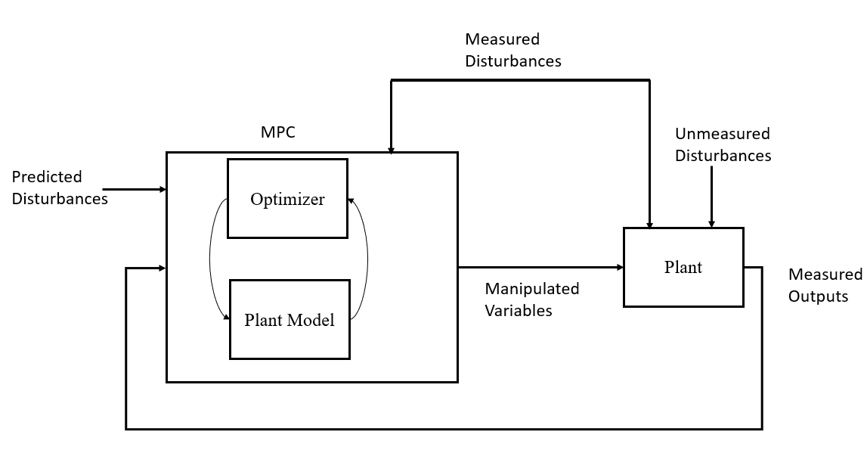

Figure 19: Structure of MPC control strategy

The figure above shows the structure of the MPC control strategy. To understand this structure, various definitions need to be introduced:

* **Plant**: The system that needs to be controlled. In this case the water tank actuated by the heat pump and electric heater.
* **Measured outputs**: The variables in the plant that need to be controlled. In this case, the variables that indicate the energy content of the tank, more specifically, the 5 temperatures across the tank.
* **Unmeasured disturbances**: The variables that influence the plant, but are not taken into account in the modelling process or the measurement system.
* **Measured disturbances**: The external variables that influence the process, but are taken into account in the modelling and the measurement system. In this case: the ambient temperature, the flow rate of water tapping from the tank.
* **Manipulated variables:** The actuators setpoint that are decided by the controller. In this case, the heat pump compressor power and the power of the electric heater.
* **Predicted disturbances:** Predictions of solar irradiation and ambient temperature.

When this structure is applied to this application, it results in the following control architecture:

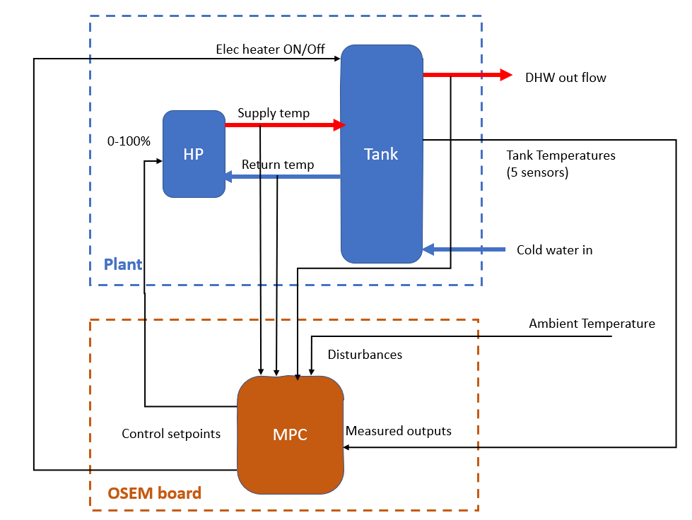

Figure 20: The realized Control structure in this application

## 5.3 The Optimization problem:

In MPC control strategy, the control signals that drive the heat pump and the electric heaters are obtained by solving an optimization problem at every sampling interval. In effect, every sampling interval k, the control law is decided by running the plant model P steps into the future. The formulation of the optimization problem consists of:

* The cost function (Objective function).
* The inequality constraints.
* The equality constraints.

The cost function is given by:

Where:

is the vector of manipulated variables that minimize the cost function over the prediction horizon p.

And u(k) is the vector of setpoints:

The variable represents the deviation between the reference values of the output (The tank temperatures), and the predicted value of the outputs.

Where is the predicted tank temperatures at time k:

And the temperatures T1 to T5 are as defined in the dynamic model presented in the previous section.

Furthermore, represents the deviation of the manipulated variables u(k) from their nominal values at time step k.

The matrices Q and R are weight matrices for the outputs and inputs, respectively. The role of the weight matrices is to “tune” the behavior of the controlled system. For example, assigning a high weight in the matrix Q relative to R will place more emphasis on keeping the temperatures of the tank close to their reference values. Conversely, assigning a high weight in R relative to Q, will place more emphasis on keeping the electric heater and heat pump power close o their nominal values on the expense of allowing the temperatures in the tank to deviate from their reference values.

The optimization problem must be solved while meeting inequality constraints for both the inputs and the outputs. Th e inequality constraints for the inputs follow from the ratings of the actuators, which can be expressed as follows:

Where and are the maximum rating power of the heat pump and the electric heater, respectively. Note that in the controller, for numerical uniformity, the control signals are normalized between zero (for zero power), and one (for maximum power).

The inequality constraints for the output temperatures follow from the health regulations of the DHW [insert reference here]. Water temperatures below 40 C can cause buildup of Legionella bacteria, while temperatures above 60 C can cause scolding burns to the skin. Based on that, the following constraint is adopted:

In addition to the inequality constraints, the solution of the optimization problem must obey the dynamics of the system as described by the model presented in the previous section. The dynamic model describes the evolution of the temperature in the water in the tank. When the model equations are linearized and discretized, they take the form of the equality constraint:

Where A and B are matrices of constants related to the parameters of the system. The linearized model will be further elaborated in the design section of this report.

## 5.5 Tuning the MPC parameters:

From the brief exposition above, the performance of the MPC is determined by the following tunable parameters:

* The controller step size (the sampling time).
* The prediction horizon p.
* The control horizon c.
* The outputs weight matrix Q.
* The inputs weight matrix R.

### 5.5.1 The controller sampling time:

The choice of the controller sampling time depends on several factors; The dominant time constants of the process, the characteristics of the actuators, and the available processing power. The choice of the sampling time should be small enough to capture the process dynamics. However, a very small sampling time is not preferable for the controller, since this will lead to excessive switching (movement) of the actuators (for example excessive change in the compressor setpoint). In addition, a very small sampling time will require the collection of large amounts of datapoints to predict the same sampling interval compared to a larger sampling time. For example, if the sampling time is chosen as 1 second, then it will require 3600 data points to predict the next hour, while the same prediction horizon (1 hour) can be achieved with 60 datapoints if the sampling interval is reduced to 1 minute. Therefore, the controller sampling time is chosen as 10 minutes.

### 5.5.2 The prediction horizon p:

A similar argument can be made about the choice of the prediction horizon p. Considering the major disturbances in this process, namely, The solar irradiation (which affects the availability and the price of electric energy), the ambient temperature (which directly affects the COP of the heat pump) and the hot water tapping profile (which directly affects the thermal energy content of the tank). The first two disturbances do not – usually- change significantly in the time scale of seconds to few minutes (Unless shading occurs). Furthermore, the thermal energy content of the water within the tank does not change significantly when there no tapping (For the majority of the day, there is no tapping). Therefore, choosing a prediction horizon of a few minutes will cause redundancy in the computations. In this work, a prediction horizon of 2 hours (12 samples) is chosen.

### 5.5.3 The control horizon c:

Control horizon c : At each controller sampling interval, the optimization problem described in the previous section is solved, the solution yields the controller “moves” for the next p interval (i.e a vector of p elements representing the controller moves). The control horizon refers to how many of these moves are actually sent to the controller. For instance, if the control horizon is set to c=1, only the next controller move is sent to the actuator, while the rest is discarded. If the control horizon is set to c =p, then all the next p controller moves are determined at the current time step. In this application, the control horizon is set to 1. This allows the controller to respond to deviations between the predicted disturbances and the actual disturbances.

### 5.5.4 The output weight matrix Q:

As mentioned above, the matrix Q in the cost function “punishes” the deviation of the output from the reference value. The matrix Q is a 5x5 matrix (Since the system has 5 outputs) whose diagonal elements represent the weight of each output. In this work, the convention used for the weights is that the value of each weight is between zero and one (Zero: output not important at all. One: Output is the most important).

The goal of the MPC is to satisfy the demand of DHW while minimizing the required energy. Therefore, it is reasonable to design this matrix in relation to the daily hot water profile. In other words, when there is hot water demand, The output weight should be high, which will ensure the hot water is close to the reference value. Conversely, in periods where there is no demand (e.g at night while occupants are asleep), the output weight can be lower and therefore the temperature of the hot water is allowed to drift (while still being within the constraint value).

Furthermore, since the hot water demand is always extracted from the upper layer of the tank, the controller’s cost function will focus on the upper two layers. This results in the following output weight matrix.

In this iteration of the application, the implementation of Q was simplified to:

By placing a high weight on the temperatures of the upper layers, the controller ensures that the setpoints for the upper layers are followed. Placing a zero weight on the temperatures of the lower layers of the tank will allow it to drop without the controller having to spend energy heating the lower layers. This contributes to minimizing the energy spent, while maximizing the useful energy content of the tank.

### 5.5.5 The input weight matrix R:

In the cost function, the input weight matrix R punishes the deviation of the inputs from the reference point. Since the inputs of the system are the electric power to the compressor, and the electric power to the electric heater, the choice of the input weights directly affects the energy consumption of the system.

The input weight matrix is a 2x2 matrix (because there are 2 inputs) with the weights on the diagonal. A similar convention is used for the values of the input weights. The weight is a number between zero and one, where zero means the input will not be punished at all, while a value of one means the input will be punished the most.

The choice of the weights of the inputs can be motivated in relation to the device characteristics. For example, the electric heating element can be used when there is an abundance of solar energy. Therefore, the weight of the electric heater can be chosen as inversely proportional to the PV power. Alternatively, if dynamic prices of electricity exist, the weight can be chosen proportional to the price of electricity.

Now, a similar reasoning can be applied to the choice of the weight of the heat pump compressor. The use of the heat pump is preferred when the COP is high. In other words, the weight of the Heat pump compressor power is a function of the ambient temperature.

In this specific realization, the values or R were implemented as:

In this simplified expression of R, a higher weight is set on the electric heater, which means the controller will only choose to activate the electric heater when the temperatures in the upper tank are highly deviating from the setpoints (Recall that deviation of the upper tank is punished by a weight of 10). Setting a zero weight on the heat pump will allow the controller to activate it freely without adding to the cost function. This will allow the controller to operate the heat pump to regulate the temperatures of the upper layers in the tank.

## 5.6 Controller Design in Simulink:

The previous section presented the structure of the MPC and the choice of the various parameters. This section presents the design and simulation of the MPC in Simulink. Model Predictive Control Toolbox™ provides functions and Simulink® blocks for designing and simulating controllers using linear and nonlinear model predictive control (MPC). The toolbox lets the user specify plant and disturbance models, horizons, constraints, and weights. By running closed-loop simulations, the user can evaluate controller performance.

The figure below shows the structure of the MPC and the plant in Simulink. The “MPC controller” block has 3 input ports and one output port. The input ports are the reference temperature for the 5 layers in the tank, the ‘MO’ port is connected to the measured outputs of the plant (The 5 temperatures). The ‘MD’ port is connected to the measured disturbances (the ambient temperature and the DHW usage profile).

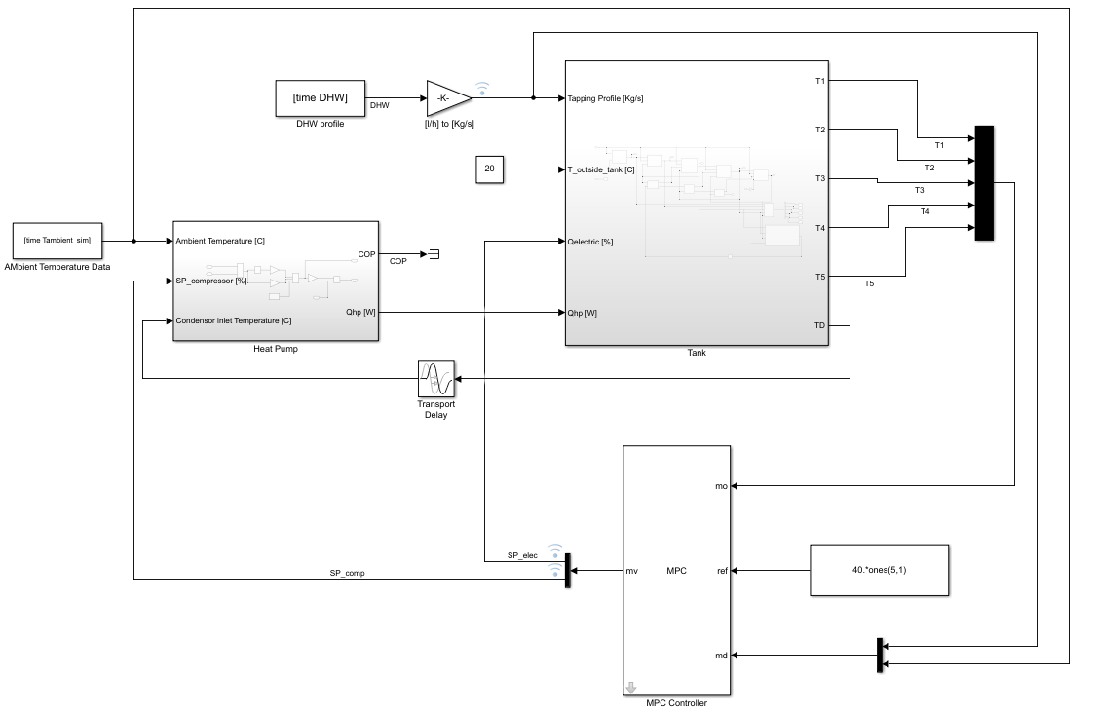

Figure 21: Structure of the MPC and the plant in Simulink

*Note:*

*In the modelling chapter, a model of the PV was presented. However, the PV was left out from the implementation shown in the above figure. The reasons are:*

* *In the experimental testing phase, there are no PV panels attached to the system.*
* *The PVs are not part of the system dynamics. The PVs are only a source of energy to the system but do not influence the internal dynamics of the system (i.e the temperature of the tank and the COP of the HP). Therefore, the PVs can be removed without affecting the accuracy of the model in predicting the dynamics of the HP and the tank.*
* *The difference between the case where PV is present and where PV is removed will be on the Weights of the controller. As explained in section 5.5, measurement of PV production can be used to tune the MPC weights.*

The MPC design procedure in Simulink starts with specifying the controller structure. The structure has been defined in the previous section. It can be seen that the structure on the simulation mirrors the structure presented in figure 20 in the previous section It’s implemented in Simulink as follows:

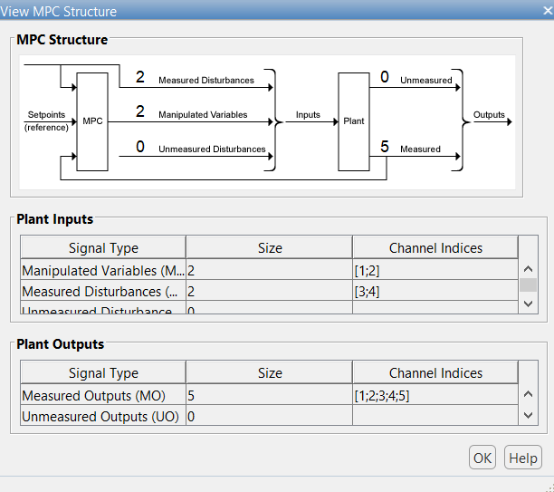

Figure 22: Defining the controller structure in Simulink

After defining the controller structure, the input/output signal attributes must be defined. The attributes of a signal are its name, unit, nominal value and scale factor. The system has 3 input signals, 2 of them are manipulated variables: The electric heater set point and the heat pump compressor setpoint. In addition to one measured disturbance ‘MD’, which is the flow rate of the DHW.

The scale factors are used in order to make the terms of the cost function numerically in the same order of magnitude. Originally, the output signals (i.e the temperatures) are in [C], while the input signals (i.e the setpoints) are always between zero and one. Therefore, the output signals are always about 40 times higher in magnitude than the input signals. This will result in making the changes in the input signals to become insignificant in the cost function, which is undesirable. Therefore, scale factors are introduced.

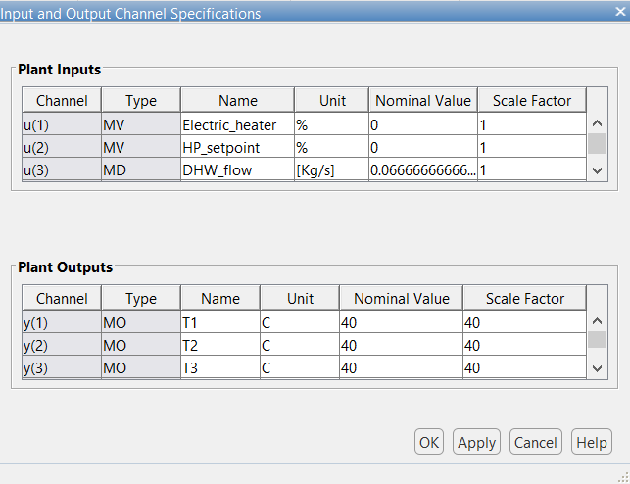

Figure 23: Specifying the input/output channel attributes

The next step in the design procedure is to define the internal model that the MPC will use for prediction. As mentioned before, the model equations will represent the equality constraints for the optimization problem. The model presented in the previous chapter contains several nonlinearities and will therefore need to be linearized.

Generally, a nonlinear dynamic model will have the form:

Where x(t) is the state vector, u(t) is the input vector and f is the function that relates the derivates of the states to the states and inputs. This model can be linearized by, first selecting an operating point . Then the linear state space matrices can be found by:

Which results in the standard linear state space model:

This continuous time state-space model can be discretized according to the relations:

Where and are the discrete-time equivalent state space matrices. Ts is the sampling time. This gives the following discrete-time state space description:

In Simulink, the linearization and discretization can be carried out during the design. The operating point for linearization was chosen as 40 [C]. This is a reasonable choice since the system will always be controlled around this temperature.

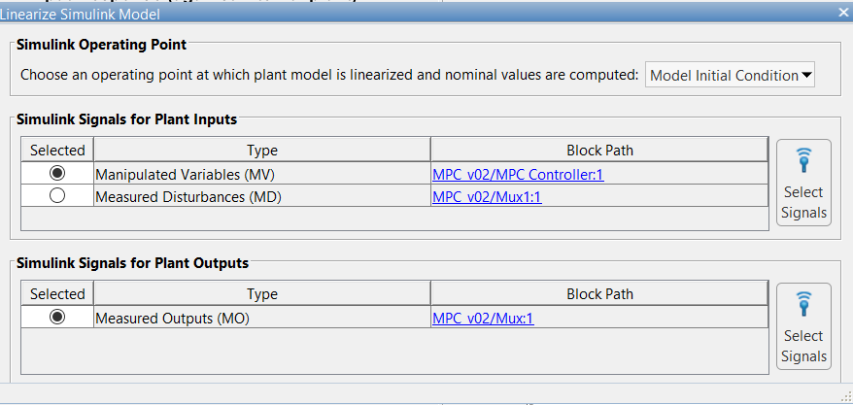

Figure 24: Model linearization for MPC design

This results in the following linear model matrices A and B:

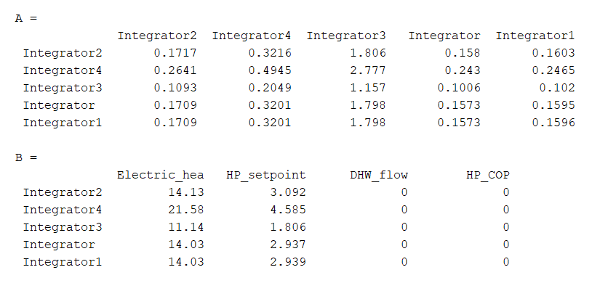

Figure 25: The linearized model computed by Simulink. Linearized at operating point 40 [C]

Next, the constraints values are set for the input and output variables. As explained before, the input constraints follow from the physical properties of the actuators. A setpoint can only be between 0% and 100%. The constraints on the output temperature follows from the health guidelines, a minimum temperature of 40 is required to prevent the buildup of bacteria, while temperatures above 60 [C] can cause scolding of the skin. The constraint for the upper two layers in the tank was chosen as 55 [C]. Notice that the max constraint for the lower layers was left as ‘infinite’. This has no effect on the controller, since the dynamics of the tank dictate that the upper layers (which are already constrained) will always have a higher temperature than the lower layers.

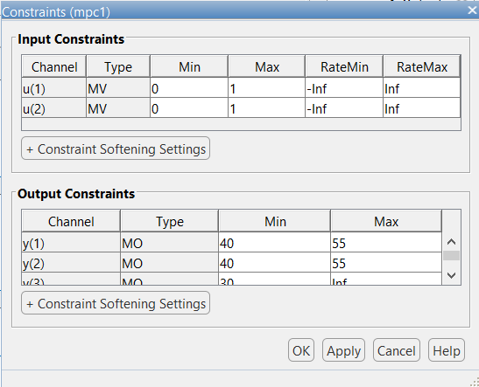

Figure 26: Constraints on the input and output variables

## Verification of the design

The previous section detailed the design procedure of the model predictive controller. This section will present the analysis and the tests performed in order to ensure the stability and robustness. The figure below shows the summary of the tests performed and their outcomes.

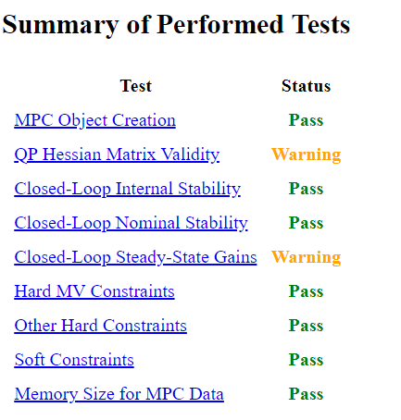

Figure 27: Summary of the performed tests

* **MPC Object Creation:**  Test whether the controller specifications generate a valid MPC controller. And that no errors exist in the code.
* **QP Hessian Matrix Validity:** The MPC applies quadratic programming (QP) to solve the optimization problem. For the QP problem to have a unique solution, the QP’s Hessian matrix must be positive definite. One way to guarantee a positive -definite Hessian is setting weights of the manipulated variables rate comparable to the manipulated variables weight. However, as a design choice, no weight was imposed on the rate of the manipulated variable, hence the warning. Nevertheless, the test is passed because the Hessian matrix was indeed positive-definite.
* **Closed-Loop Internal Stability:** This test extracts the A matrix from the unconstrained controller's state space realization, and then calculates its eigenvalues. The absolute value of each eigenvalue was less than 1, therefore the plant is stable.
* **Closed-Loop Nominal stability:** This test obtains the discrete-time state-space realization of the closed-loop system -- the plant and controller connected in a feedback configuration. It extracts the A matrix from this and calculates its eigenvalues. The absolute value of each such eigenvalue was found to be less than 1. Therefore, the nominal (unconstrained) system is stable.
* **Closed-Loop Steady-State Gains:** This test determines whether the controller forces all controlled output variables to their targets at steady state, in the absence of constraints. Now, in this system, there are 2 actuators and 5 output variables (System is “underactuated”). Furthermore, the interconnection between the tank layers would prevent all of the 5 temperatures to be driven to arbitrarily chosen references. The test concludes, as expected, that this cannot be done. However, since it’s not important for the system to control each layer temperature independently. This is not an issue.

# Controller Simulations:

To verify the design presented in the previous chapter, several simulation tests has been performed on the controller and plant model. This chapter describes the tests performed and the simulation results.

The first test is aimed to verify how the controller would perform on a winter day. For that purpose, datasets of solar irradiance and ambient temperature from the Royal Netherlands Metrological Institute (KNMI) data platform [26]. The datasets are the weighted average of hourly measurements over the past 30 years.

Furthermore, the DHW draw-offs profile used in this simulation was obtained from the European directive with regards eco-design requirements for water heaters and hot water storage tanks [27]. Other synthetic loads profiles are available too, examples are in the software from university of Twente [28] and a software tool from the university of Kessel [29]. Both software tools produce comparable profiles that are accurate representative of the DHW consumption profile in the Dutch households.

The figure below depicts the datasets used in the simulation:



Figure 28: Datasets used for testing scenario 1

The system is simulated for a period of one day. The key results are depicted in the following figures



Figure 29: Simulation Results. Temperatures within the tank

The initial condition of the tank temperature was set to 30 (for all layers). At the start, the electric heater assists with bringing the temperature of the upper layer (T1) to the desired temperature (40C). Afterwards, only the heat pump is used to regulate the temperature during draw-offs of DHW.



Figure 30: Simulation Results. Control signals

Another simulation test was performed. The purpose of this test is to verify the controller performance under more extreme conditions. A winter day was chosen, when ambient temperature is low, resulting in a low COP of the heat pump. Furthermore, the draw-off profile used in this test is double the standard amount which was used in the previous test. The datasets used are summarized in the figure below



Figure 31: Datasets used in the test

The simulation results show that the controller is able to maintain the temperature at the desired value. The temperatures of the lower parts of the tank drop below 40 C due to the injection of cold water. However, the upper layers, from which DHW is drawn, remain at the desired temperature



Figure 32: Temperatures within the tank

The figure below shows the control signals. It is observed that the electric heater is turned on at the start to assist with bringing the temperature from the initial condition at 30C, to the desired temperature at 40C. Once the temperature begins to approach 40 C, the electric heater is turned off and only the heat pump is modulated to maintain the temperature drops due to DHW draw-off.



Figure 33: Heat pump and electric heater control signals

# Discussion & Conclusions

The controller was designed with 2 goals in mind; The first is to satisfy the DHW with the setpoint temperature (In this case 40 [C]). The second goal was to achieve the first goal in an optimal manner, we defined optimality as prioritizing the heat pump (More efficient use of electric energy which contributes to minimizing the energy used in the system), and also prioritizing the heating of the upper layers (The upper layers are the ones from which DHW is drawn. When the upper layers are kept hot while the lower layers are allowed to cool down, this maintains the stratification of the tank and thereby maximizes the useful energy content of the tank. A mixed tank may contain “theoretically” the same amount of energy, but it’s not useful for DHW purposes).

With these 2 goals in mind, we can examine the results presented in the previous section. Figure 32 shows the temperatures inside the tank. The initial condition was 30 C while the setpoint was 40 C. It can be seen that the controller quickly brings the temperatures up to the setpoint and maintains it until the 1st DHW tapping of the day (Around 07:00 AM). Without the controller, the tapping would cause a sharp drop in the temperature since the hot water is replaced by cold water. To counter this effect, the controller overshoots a bit (by around 1 degree [C]) such that when tapping occurs, the upper layers will drop back to the required 40 [C]. It’s important to observe that the lower layers of the tank are allowed to drop significantly (to 35 [C]). Thereby confirming the goals that we started with.

Now the attention is turned to figure 33 which shows the control action. At the start, the temperatures of the tank highly deviate from the setpoint. The electric heater is brought on with maximum power but for a short period of time to bring the temperatures to the setpoint. After that, the electric heater is not utilized at all, and the more efficient heat pump is utilized to maintain the temperatures at 40C and to counter the effects of DHW tapping. This gives an indication that Goal 2 is achieved.

It can be concluded from this discussion that the simulation results confirm the design goals. The main observations being:

* Temperatures of the upper layers are maintained at the setpoint.
* The heat pump is prioritized over the electric heater.
* The temperatures of the lower layers are allowed to drop.

On simulation level, the controller behaves as expected from the design. This gives confidence to move to the next phase. That is deploying the controller on the hardware and carrying out lab tests. The controller will be subjected to more rigorous testing. And more meaningful results relating to the energy consumption and performance of the controller can be drawn from that.

# Controller Implementation:

The previous chapters dealt with the design, verification, and simulation of the controller, which was done in MATLAB/ Simulink. This chapter deals with the controller implementation on the hardware. In separate WP of this project, the hardware architecture is discussed in detail. The figure below shows the hardware architecture.

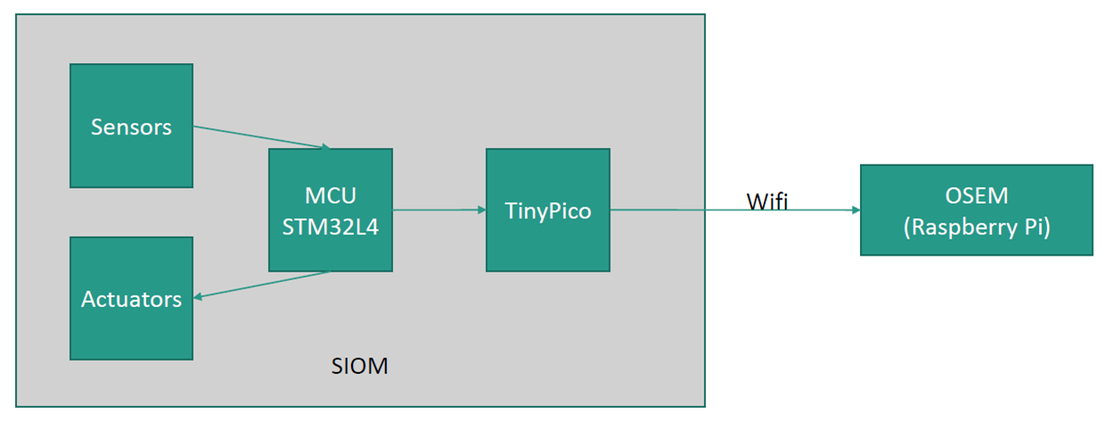

Figure 34: Hardware architecture for controller implementation

In this architecture, the sensors and actuators are interfaced via an MCU STM32L4 microcontroller. The MCU communicate with the TinyPcio via I2C where the TinyPco sets the MCU's output via output register and the MCU pushes the measurement data every second to the TinyPico via the input register.

Between the TinyPico microcontroller and the Raspberry Pi, a WIFI connection is established. MQTT protocol is used to pass the sensor measurements and setpoints.

As mentioned before, the detailed hardware design is the subject of a separate WP in this project. In this section, the focus will be on the implementation of the model predictive controller into the RPI processor. Since the design, verification and simulation tests were done in Simulink environment, the implementation of the MPC controller will be performed with the same tool.

## Raspberry Pi Support from Simulink

Simulink® Support Package for Raspberry Pi allows to develop algorithms that run standalone on Raspberry Pi. The support package extends Simulink with blocks to drive Raspberry Pi I/O and read and write data from them. After creating the Simulink model, the user can simulate it and download the completed algorithm for standalone execution on the device. One particularly useful (and unique) capability offered by Simulink is the ability to tune parameters live from the Simulink model while the algorithm runs on the hardware.

The procedure to generate a C++ code and deploy it on the target Raspberri will not be listed in detail in this document. The reader is referred to the Mathworks documentation [30] on the topic, which includes articles, step by step guides, tutorial videos, and example codes.

The main layer of the controller deployed code is shown below. As can be seen from the figure, the structure mimics the conventional controller feedback loop. It consists of 4 main blocks.

* Sensors block: Within this block, sensor data is acquired via MQTT subscription topics.
* MPC controller block: In this block, the controller is defined, as detailed in the previous chapter.
* Actuator block: This block transmits the setpoints via MQTT published topics.
* Data plots block: This block visualizes the sensor and actuator data, in addition to the disturbances.

The complete code is available at the Github repository [31] of the OSEM project. In the repository, a separate documentation explains in step-by-step guide how to deploy the controller on raspberry pi hardware.

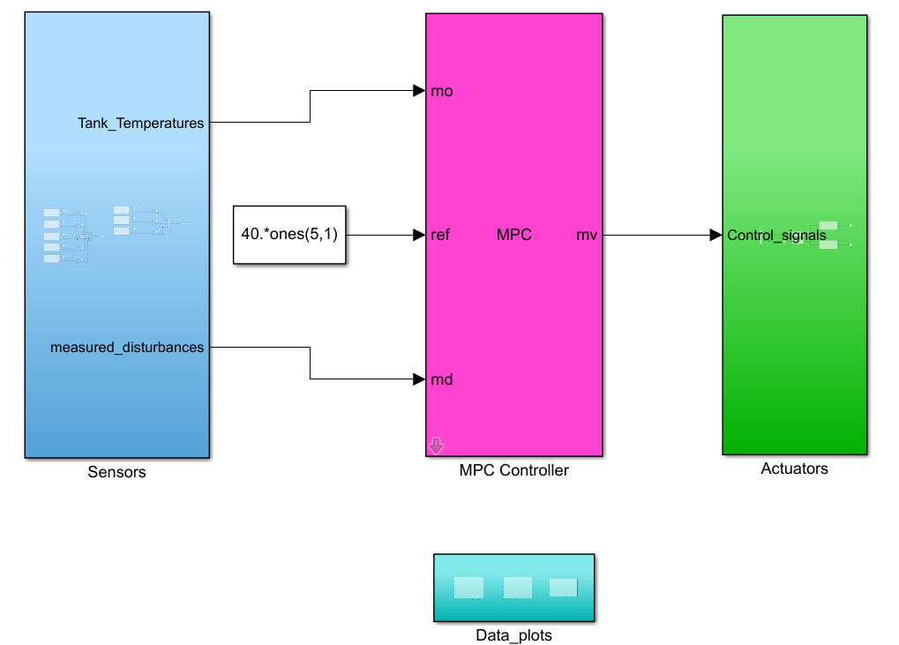

Figure 35: Main layer of the deployed controller code

# Bibliography

|  |  |
| --- | --- |
| [1] | D. Rolando, H. Madani, G. Braida, R. Tomasetig and Z. Mohammadi, "Heat pump system control: the potential improvement based on perfect prediction of weather forecast and user occupancy," in *12th IEA Heat Pump Conference*, 2017. |
| [2] | M. Dannemand, B. Perers and S. Furbo, "Performance of a demonstration solar PVT assisted heat pump system with cold buffer storage and domestic hot water storage tanks," *Energy and Buildings,* vol. 188, p. 46–57, 2019. |
| [3] | F. D'Ettorre, P. Conti, E. Schito and D. Testi, "Model predictive control of a hybrid heat pump system and impact of the prediction horizon on cost-saving potential and optimal storage capacity," *Applied Thermal Engineering,* vol. 148, p. 524–535, 2019. |
| [4] | D. e. a. Rolando, "Heat pump system control: the potential improvement based on perfect prediction of weather forecast and user occupancy," *12th IEA Heat Pump Conference. 2017.,* 2017. |
| [5] | "Installer Reference Guide: DAKIN Atherma low-temperature heat pump". |
| [6] | M. Trčka and J. L. M. Hensen, "Overview of HVAC system simulation," *Automation in Construction,* vol. 19, p. 93–99, 2010. |
| [7] | M. Trcka and J. L. M. Hensen, "HVAC system simulation: Overview, issues and some solutions," in *Proc. of the 23rd IIR International Congress of Refrigeration. Presented at the 23rd IIR International Congress of Refrigeration, International Institute of Refrigeration, Prague*, 2011. |
| [8] | BEST, *Building Energy Software Tools (BEST) directorry.* |
| [9] | P. A. Strachan, G. Kokogiannakis and I. A. Macdonald, "History and development of validation with the ESP-r simulation program," *Building and Environment,* vol. 43, p. 601–609, 2008. |
| [10] | DOE, *EnergyPlus.* |
| [11] | L. L. C. Thermal Energy System Specialists, *Transient System Simulation Tool.* |
| [12] | E. Vuong, R. S. Kamel and A. S. Fung, "Modelling and simulation of BIPV/T in EnergyPlus and TRNSYS," *Energy Procedia,* vol. 78, p. 1883–1888, 2015. |
| [13] | D. Mazzeo, N. Matera, C. Cornaro, G. Oliveti, P. Romagnoni and L. De Santoli, "EnergyPlus, IDA ICE and TRNSYS predictive simulation accuracy for building thermal behaviour evaluation by using an experimental campaign in solar test boxes with and without a PCM module," *Energy and Buildings,* vol. 212, p. 109812, 2020. |
| [14] | I. Beausoleil-Morrison, F. Macdonald, M. Kummert, T. McDowell and R. Jost, "Co-simulation between ESP-r and TRNSYS," *Journal of Building Performance Simulation,* vol. 7, pp. 133-151, 2014. |
| [15] | T. X. Nghiem, *MLE+: a Matlab-EnergyPlus co-simulation interface,* 2010. |
| [16] | C. Koulamas, A. P. Kalogeras, R. Pacheco-Torres, J. Casillas and L. Ferrarini, "Suitability analysis of modeling and assessment approaches in energy efficiency in buildings," *Energy and buildings,* vol. 158, p. 1662–1682, 2018. |
| [17] | D. Rolando and H. Madani, "Smart Control Strategies for Heat Pump Systems," *Kyla+ Värmepumpar,* 2018. |
| [18] | A. I. Dounis and C. Caraiscos, "Advanced control systems engineering for energy and comfort management in a building environment—A review," *Renewable and Sustainable Energy Reviews,* vol. 13, p. 1246–1261, 2009. |
| [19] | E. Atam and L. Helsen, "Ground-coupled heat pumps: Part 1–Literature review and research challenges in modeling and optimal control," *Renewable and Sustainable Energy Reviews,* vol. 54, p. 1653–1667, 2016. |
| [20] | S. Wang and Z. Ma, "Supervisory and optimal control of building HVAC systems: A review," *Hvac&R Research,* vol. 14, p. 3–32, 2008. |
| [21] | I. Staffell, "A review of domestic heat pump coefficient of performance," *Birmingham University,* 2009. |
| [22] | S. J. Qin and T. A. Badgwell, "A survey of industrial model predictive control technology," *Control engineering practice,* vol. 11, p. 733–764, 2003. |
| [23] | C. Ekaputri and A. Syaichu-Rohman, "Implementation model predictive control (MPC) algorithm-3 for inverted pendulum," in *2012 IEEE Control and System Graduate Research Colloquium*, 2012. |
| [24] | J. B. Rawlings, "Tutorial overview of model predictive control," *IEEE control systems magazine,* vol. 20, p. 38–52, 2000. |
| [25] | W. S. Levine, L. Grüne, R. Goebel, S. V. Rakovic, A. Mesbah, I. Kolmanovsky, S. Di Cairano, D. A. Allan, J. B. Rawlings, M. A. Sehr and others, "Handbook of model predictive control," 2018. |
| [26] | M. Arnold, R. R. Negenborn, G. Andersson and B. De Schutter, "Multi-area predictive control for combined electricity and natural gas systems," in *2009 European Control Conference (ECC)*, 2009. |
| [29] | A. Afram and F. Janabi-Sharifi, "Theory and applications of HVAC control systems–A review of model predictive control (MPC)," *Building and Environment,* vol. 72, p. 343–355, 2014. |